Chapter 4

**Water Quality Statistics**

We developed a series of linear mixed effects models to estimate concentrations for constituents of concern (COCs) in Puget Sound urban stormwater. Spatial covariates in the models included various landscape predictors, rainfall, and in some models, percent land use (commercial, industrial, residential).

**4.1 Data Sources**

**4.1.1 Outfall Data**

The primary source of measured stormwater data is the S8.D Municipal Stormwater Permit Outfall Data (referred to as the S8 Data in this document) provided by the Washington Department of Ecology (William Hobbs et al. 2015). Special Condition S8.D of the 2007-2012 Phase I Municipal Stormwater Permit required permittees to collect and analyze data to evaluate pollutant loads in stormwater discharged from different land uses: high density (HD) residential, low density (LD) residential, commercial, and industrial. Phase I Permittees[1] collected water quality and flow data, sediment data, and toxicity information from stormwater discharges during storm events. Stormwater data collected from a total of 16 outfalls by six Phase I Permittees was utilized in this modeling study.

The stormwater outfall data is available from Ecology via an open-data api at: https://data.wa.gov/Natural-Resources-Environment/Municipal-Stormwater- Permit-Outfall-Data/d958-q2ci.

COCs analyzed in this study are:

* Copper – Total
* Total Suspended Solids (TSS)
* Phosphorus – Total
* Nitrite-Nitrate – Dissolved – still to be analyzed
* Zinc – Total – still to be analyzed
* Zinc – Dissolved – still to be analyzed

We extracted data for these COCs, and performed minimal data cleaning. We filtered out rejected data (values with a R or REJ flag), removed replicates, and removed one data point for Nitrite-Nitrate that was an obvious outlier (an order of magnitude higher than the rest of the data). Figure 4.1 shows data before removal of the outlier.

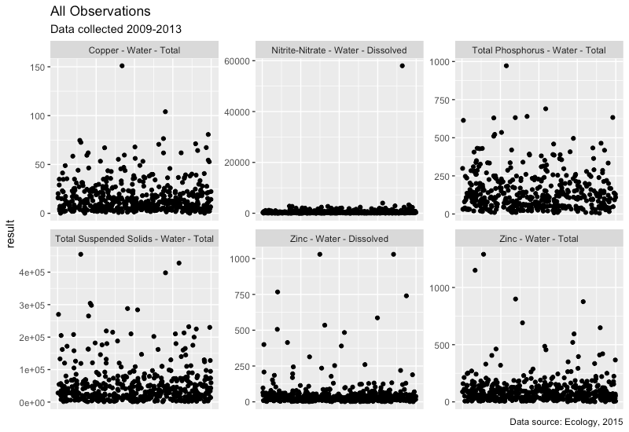

**Figure 4.1**  All observations with outlier in place for Nitrite-Nitrate

**4.1.2 Censored (Non-Detect) Data**

Nearly all COCs had non-detect (left-censored) data present (Table 4.1). Ecology flagged non-detect data and provided the reporting limit for each non-detect value. All COCs had a very small percentage of data that were non-detect (2% or less); non-detect values were substituted with one-half of the reporting limit.

**Table 4.1** Percentage of data points that were left-censored (non-detect) for each chemical of concern.

|  |  |  |
| --- | --- | --- |
| **Chemical of Concern** | **Censored Data Percentage** | **Notes** |
| Total Copper | 0% | 4 samples were field blanks misclassified as ND’s. Censored data percentage was calculated following removal of these 4 field blanks. |
| Nitrite-Nitrate | 0.23% |  |
| Phosphorus | 1.17% | 3 samples with high results were classified as ND’s, but should have been flagged as “estimated”. Censored data percentage was calculated following reclassification of these 3 data points. |
| Total Suspended Solids | 0.83% |  |
| Dissolved Zinc | 0.22% | 4 samples were field blanks misclassified as ND’s. 2 samples with high results were classified as ND’s, but should have been flagged as “estimated”. Censored data percentage was calculated following reclassification of these 6 data points. |
| Total Zinc | 0% | 4 samples were field blanks misclassified as ND’s. Censored data percentage was calculated following removal of these 4 field blanks. |

**4.1.3 Transformation of outfall data**

Each COC was then evaluated for its underlying distribution, to determine whether transformation would be beneficial prior to running a linear mixed effects model on the results. Quantile-quantile plots (QQ plots) using a normal distribution, gamma distribution, square-root transformed distribution, and log-transformed distribution were visually analyzed. For all COC’s, log-transformation was deemed an appropriate data transformation prior to model analysis (Fig. 4.2).

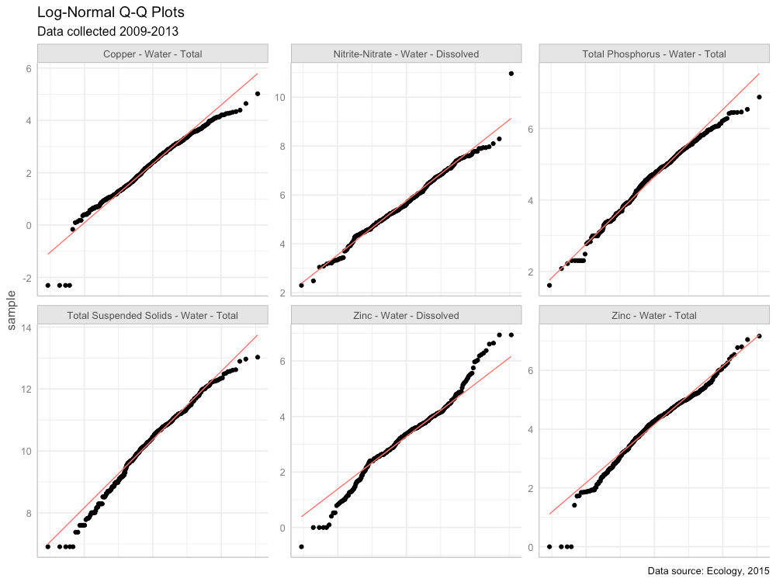

**Figure 4.2** Quantile-quantile plots of COCs using a natural-log (*ln*) scale. Red line shows the QQ-line.

**4.2 Spatial Data**

For this study, we did not rely on the permittee’s self-reported land use type to run regression models predicting pollution loading from land use. A visual scan of our land cover data layer versus self-reported land use types revealed little agreement among permittee definitions of the four land use types (high density residential, low density residential, commercial, industrial). Therefore, we compiled a suite of continuous datasets from which to run chemical loading models. We divide these into land use and landscape data.

**4.2.1 Land Use**

In order to employ a consistent analysis across different monitored watersheds we extracted land use data from the Washington Department of Commerce Land Use data set ~~Ecology’s 2010 Statewide Land use data set~~[2]. ~~Ecology generated the coverage from digital county tax parcel layers using Department of Revenue (DOR) two digit land use codes (see; WAC 458-53-030, Stratification of assessment rolls - real property).~~ Land use classes (also listed in the table in section 4.2.2) include:

* Intensive urban (includes commercial areas, apartment buildings)
* Urban residential (includes the majority of urban and suburban single-family dwellings)
* Rural residential
* Industrial

In addition, we combined some land use classes to generate additional land use classes:

* Total residential (urban residential + rural residential)
* Intensive Urban + Industrial; the industrial land use category did not have many non-zero data points

**4.2.2 Landscape Data**

For each watershed contained in the S8 dataset, potentially relevant landscape data were extracted from the following sources:

|  |  |  |
| --- | --- | --- |
| **Layer** | **ID** | **Source** |
| urban residential | urbRES | Washington State Department of Commerce, Puget Sound Mapping Project  https://www.commerce.wa.gov/serving-communities/growth-management/puget-sound-mapping-project/ |
| rural residential | ruRES |
| total residential (urban + rural) | totRES |
| intensive urban | intURB |
| industrial | IND |
| intensive urban + industrial | intURB_IND |
| impervious surfaces | impervious |  |
| paved surfaces | paved |  |
| rooftop density | roofs |  |
| urban residential rooftops | roof_urbRES | rooftop density applied to Washington State Department of Commerce Land Use data |
| total residential rooftops | roof_totRES |
| intensive urban rooftops | roof_intURB |
| intensive urban + industrial rooftops | roof_intURB_IND |
| grass & low vegetation | grass |  |
| tree cover | trees |  |
| total vegetative cover | greenery |  |
| undeveloped areas | nodev |  |
| traffic | traffic |  |
| population | popn |  |
| particulate matter 2.5um | pm25_na |  |
| particulate surface area | partSA |  |
| NO2 | no2 |  |
| carbon emissions, commercial | CO2_com | Vulcan Carbon Dioxide Emissions data set |
| carbon emissions, residential | CO2_res |
| carbon emissions, road | CO2_road |
| carbon emissions, nonroad | CO2_nonroad |
| carbon emissions, total | CO2_tot |
| slope | slope |  |
| age of development | devAge | Calculated value based on year of development |

**4.2.3 Pre-processing of spatial data**

In order to use the landscape data at an appropriate scale across the study area, spatial predictors were stacked and then convolved with a 100-meter gaussian kernel. This resulted in a “fuzzy” [this word is unclear to me – it makes me dubious that the predictors will be sufficient to identify correlations with chemicals of concern in watersheds] predictors that could apply across dataset boundaries. These values were then extracted for each monitored watershed.

Prior to use, spatial data were plotted and visually assessed for outliers (Fig. 4.3). Square-root transformation was performed on spatial data sets with outliers that were higher than the rest of the predictor’s values: popn, slope, CO2_res, CO2_com, CO2_road, CO2_nonroad, CO2_tot. The devAge spatial predictor had a low data outlier; devAge values were squared to address the low outlier. Figure 4.4 shows the spatial data following transformation.

Prior to use in models, spatial data sets were scaled and centered using the mean and standard deviation from the 14 watersheds in this study.

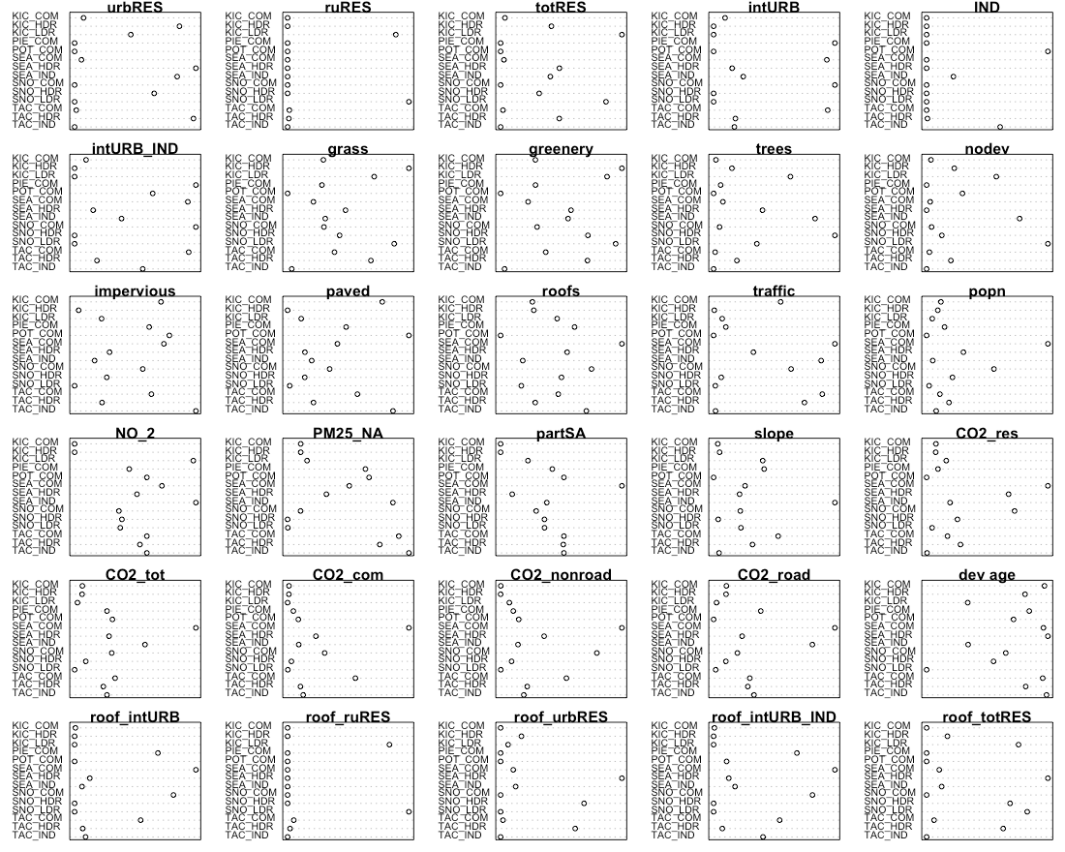

**Figure 4.3** Raw spatial data

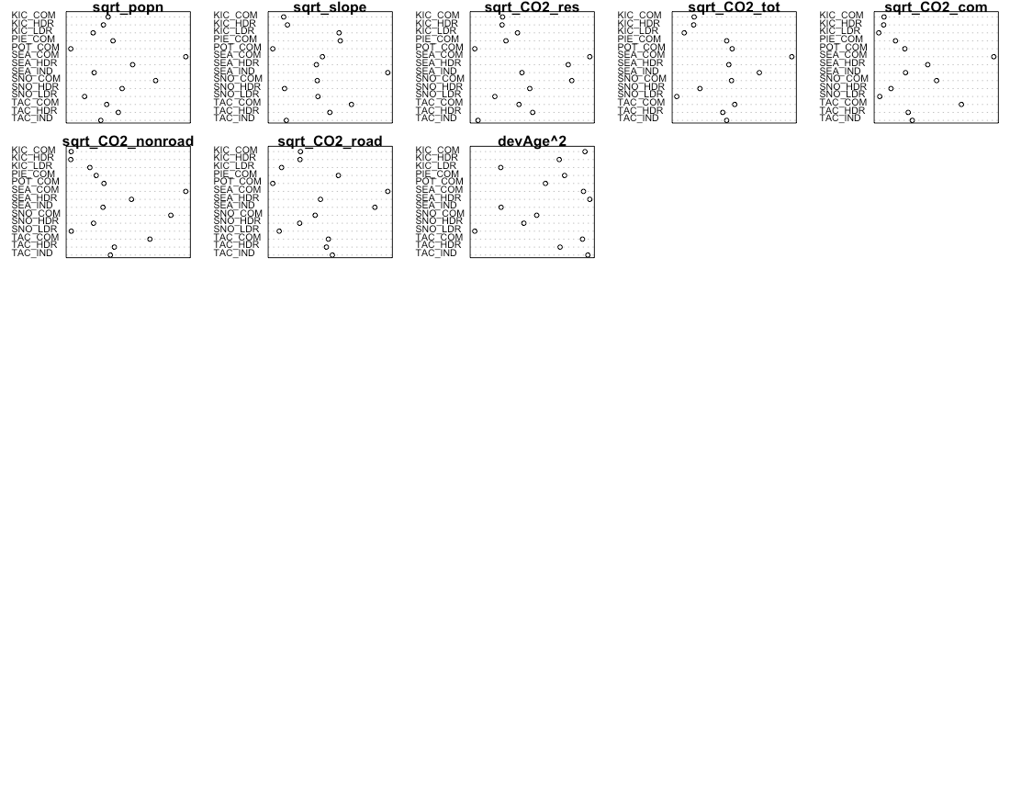

**Figure 4.4** Spatial data following transformation

**4.2.4 Precipitation Data**

Daily rainfall data were obtained from the DayMet website operated by NASA (https://daymet.ornl.gov/). Daily data were obtained for years 2009 to 2013, and cumulative one day, three day, and seven day, 14-day, 21-day and 28-day antecedant precipitation were calculated for each sampling date. For example, for a sampling date of March 22, cumulative three-day precipitation would include precipitation occurring on March 20, 21 and 22. For each COC, *ln*-transformed chemical concentrations were plotted against each precipitation measurement, and the plots were visually assessed to select the most appropriate time scale for precipitation. Cumulative 21-day precipitation was selected for copper and phosphorus, while 1-day precipitation was selected for TSS.

**4.3 Model Construction and Selection**

Model selection was performed using the methodology of Zuur et al. (2009), as outlined in the steps below.

**4.3.1 Select strong potential predictors**

The initial step was to find a suitable set of potential predictors for the COC in question. Single-predictor linear models were constructed for the relationship between *ln*-transformed chemical concentration and each landscape or land use predictor, in turn. Plots were visually assessed to determine candidate predictors for linear mixed effects models. We looked for slopes with a p-value of < 0.05, and for data points to fall roughly along the best fit model line. If prior knowledge indicated the importance of certain predictors, those were also included in the set of candidate predictors.

**4.3.2 Control for collinearity**

To prevent using highly correlated landscape parameters together in statistical models, we calculated the correlation coefficient for each pair of landscape predictors. Highly correlated landscape parameters (correlation coefficient ≥ 0.85) were not used together in any models.

**4.3.3 Control for heterogeneity (heteroskedasticity)**

Once a strong set of potential predictors was found, we constructed a generalized least squares (gls) model in R, using all potential predictors that were not highly correlated. Normalized residuals from this “beyond-optimal” were plotted against the model’s fitted values, and examined for heteroskedasticity. We also plotted residuals against agency, year, season, land use, precipitation, antecedent dry days, and all potential predictors, to look for patterns in residuals. If residual plots showed evidence of heteroskedasticity, we tried a series of gls models with different variance structures that utilized agency, season, and precipitation as variance covariates. Variance structure for each COC was selected as that of the model with the lowest Akaike information criterion (AIC) value.

**4.3.4 Find the proper random effects structure**

Next, we used the beyond-optimal model with the correct variance structure to find the proper random effects structure. The beyond-optimal gls model was compared to a linear mixed effects (lme) random intercept model, where the intercept was allowed to change per agency. Because the gls model and the random intercept model are nested, the two models were compared using the likelihood ratio test to see if one model was significantly better than the other (p-value < 0.05). The best-fit model was then selected based on the lowest AIC value. For all COCs, the random intercept model fit the data better than the gls model with no random effects.

A random intercept for agency makes sense for the stormwater data, because there were opportunities for each agency to differ slightly in sample collection methodologies. Selection of lab for sample analysis, timing of sample collection once a storm began, and any biases in selection of representative watersheds by each agency are possible factors that could lead to unintended differences in COC results. These unintended differences can be captured in the random component of the model.

**4.3.5 Check for temporal and spatial correlation**

The beyond-optimal model with the correct variance structure and random effects structure was then examined for evidence of temporal and spatial auto-correlation. Temporal auto-correlation plots were generated and visually assessed for indications of correlation between various sampling time lags; no evidence of temporal autocorrelation was found for any COC.

To assess for spatial auto-correlation, we used two methods: variograms, and spatially-explicit bubble plots of model residuals.

All tests for temporal and spatial auto-correlation were repeated following selection of best-fit models.

**4.3.6 Find the proper fixed effects structure**

We used the strong potential predictors from step 4.3.1 to generate a set of fixed-effects formulae with combinations of one, two and three potential predictors. Predictors with high correlation coefficients (>= 0.85) were not allowed to be in formulae together.

Linear mixed effects models were applied in R using the nlme package. A set of models was generated using the fixed effects formulae, along with the best-fit random effects and variance structures identified in steps 4.3.3 and 4.3.4. Models where the sign (+ or –) of the predictor coefficients did not match the coefficient signs from linear model from step 4.3.1 were discarded. Models were then sorted according to AIC value, and the top 20 models were examined for fit to individual predictors. Plots of residuals versus fitted values, agency, location, and predictors were also examined. Based on these data, one to three models were selected for further consideration. These models all had low AIC values, decent residual plots, and good fit to individual predictors

Using knowledge of chemical contaminant mobilization into stormwater, we selected the best landscape predictor model for each COC.

**4.3.7 Final model comparison**

Three models were ultimately compared for each COC:

1. **Null Model:** COC concentration is equal to median COC concentration over all sampling dates and locations
2. **Categorical Land Use Model:** COC concentration is modeled as a linear mixed effects model, utilizing land use category (HDR, LDR, COM, IND), precipitation (rainfall and/or antecedent dry days), and season (for COCs where a seasonal trend appeared in the data).
3. **Landscape Predictor Model:** COC concentration is modeled as a linear mixed effects model, utilizing up to three landscape predictors, precipitation (rainfall and/or antecedent dry days), and season (for COCs where a seasonal trend appeared in the data).

**4.4 Results**

Results for each COC are provided below.

**4.4.1 Copper**

Based on linear models of *ln*-transformed copper versus individual predictors, the strong predictors identified for copper include: intURB, intURB_IND, totRES, grass, greenery, impervious, nodev, traffic, sqrt_popn, pm25_na, sqrt_CO2_tot, sqrt_CO2_com, sqrt_CO2_road, sqrt_CO2_nonroad, devAge2, roof_intURB_IND (Fig 4.5).

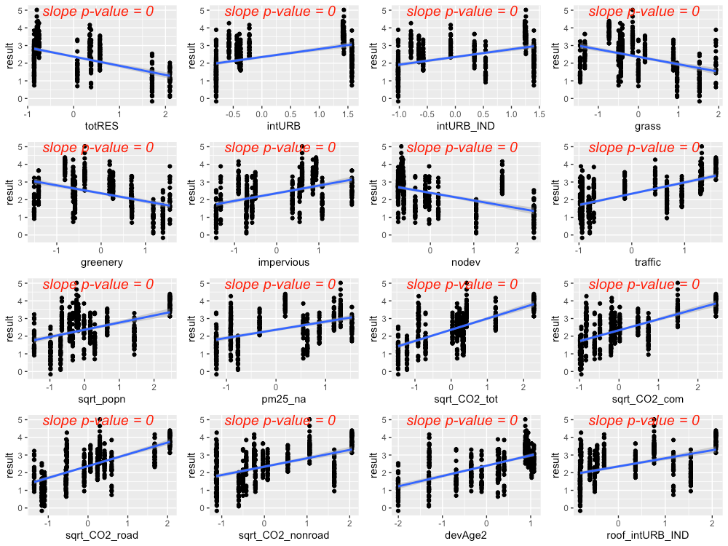

**Figure 4.5** Strong predictors for copper, showing linear model fit (blue line) for the relationship between *ln*-transformed copper concentration and each predictor in turn.

The precipitation predictor used for copper was 21-day cumulative precipitation. In addition, evidence of higher copper concentrations during summer lead us to add *summer* as a categorical predictor to the copper model (where *summer* = 1 during July, August, September, and *summer* = 0 for all other months).

Residuals plotted against fitted values showed signs of slight heterogeneity (Fig 4.6, left plot). Of the variance structures tested, the best fit was for a combination of two variance structures, where residual variation differs by agency *j*, and also by rainfall at each location *i* and date *k*. Parameters δ1 and δ2 are estimated by the model.

var(*εijk*) = σ2*j* × (δ*1*+ |*rainik*|δ*2*)2

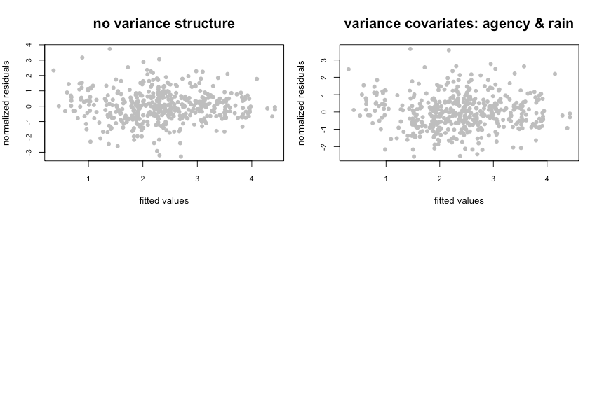

**Figure 4.6** Normalized residuals from beyond-optimal model, with no variance structure (left), and with the best fit variance structure (right).

The best model for copper is a random-intercept model, where the intercept of the linear model is allowed to shift up or down according to agency. No signs of temporal or spatial auto-correlation were detected in auto-correlation plots or variograms.

With the variance structure and random components set, two possible models emerged to capture the fixed effects:

*ln*(copper) ~ rain + summer + traffic + totRES

ln(copper) ~ rain + summer + traffic + devAge2 + pm25_na + rain × pm25_na

The first model’s AIC score was lower than that of the second model (AIC=743.4 vs. 750.5, when models were fitted with ML); however, the model coefficient for totRES is negative, indicating that increased residential zoning results in reduced copper concentrations in stormwater. This relationship makes sense for the 14 watersheds in our study, but would likely not be appropriate for forested landscapes that have low residential zoning (thus should have high copper concentrations). As a result, we selected the second model as the most suitable for covering the entire area of the stormwater heatmap. Figure 4.7 shows the model fit for each individual predictor, plotted against data points. Figure 4.8 shows the interaction between rain and pm25_na, with higher pm25_na values in reds and oranges, and lower pm25_na values in blues and purples. This interaction shows that, when pm2.5 values are high, increasing amounts of rainfall result in a dilution of copper in stormwater.

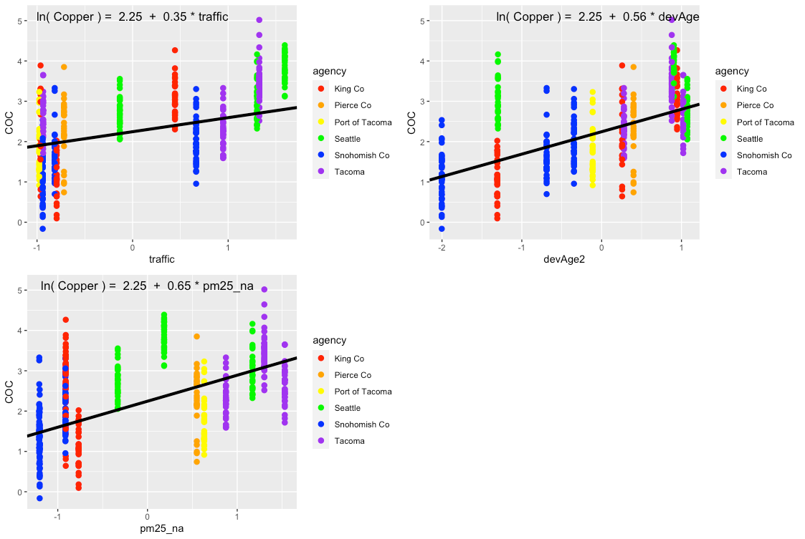

**Figure 4.7** Single-predictor plots for copper, fit of the Landscape Predictor Model to each predictor in turn.

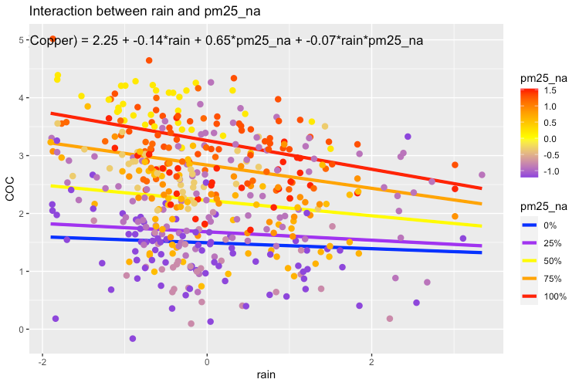

**Figure 4.8** Plot showing the interaction between rain and pm25_na that is present in the best fit model. In areas with high pm25_na values, increasing amounts of rain result in a dilution of copper in stormwater.

Comparisons between the Null Model, Categorical Land Use Model, and Landscape Predictor Model can be visualized through residuals (Fig. 4.9) and also coefficient values (Table 4.2; Fig. 4.10). Although the AIC value for the Categorical Land Use Model is lower than that of the Landscape Predictor Model, we are not confident in the transferability of the Categorical Land Use Model to watersheds outside of the 14 in this study. Two of the land use categories (Industrial – IND; and Low Density Residential – LDR) each have only two watershed representatives in our study. This results in good model fit to the data, but not necessarily for all watersheds in Puget Sound area.

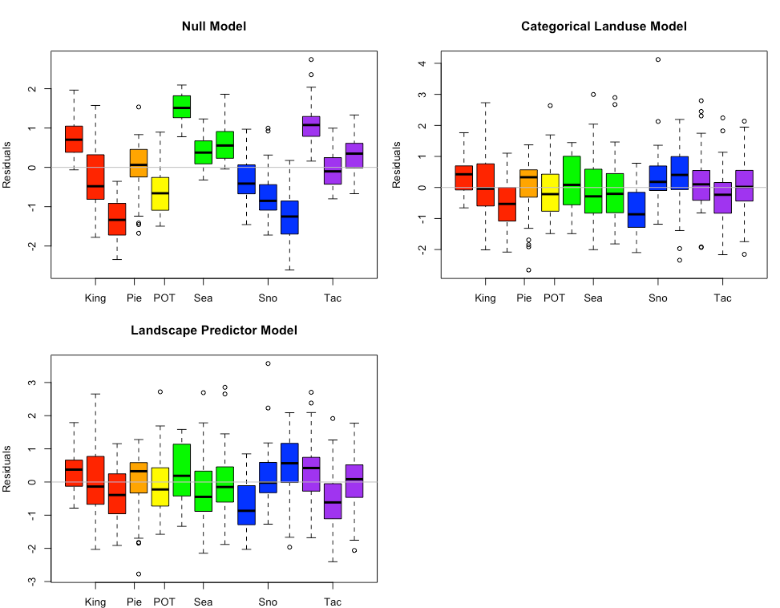

**Figure 4.9** Copper model residuals for the Null Model, Categorical Land Use Model, and Landscape Predictor Models. Each bar represents one watershed, with colors representing agencies.

**Table 4.2** Coefficient values (standard error in parenthesis) for the three copper models. For the Categorical Landuse Model, the baseline landuse is LDR; all other land use categories are adjustments from the baseline. Final coefficient values for linear mixed effects models are based on fitting with REML.

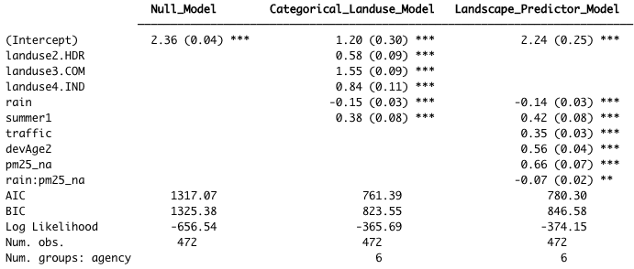

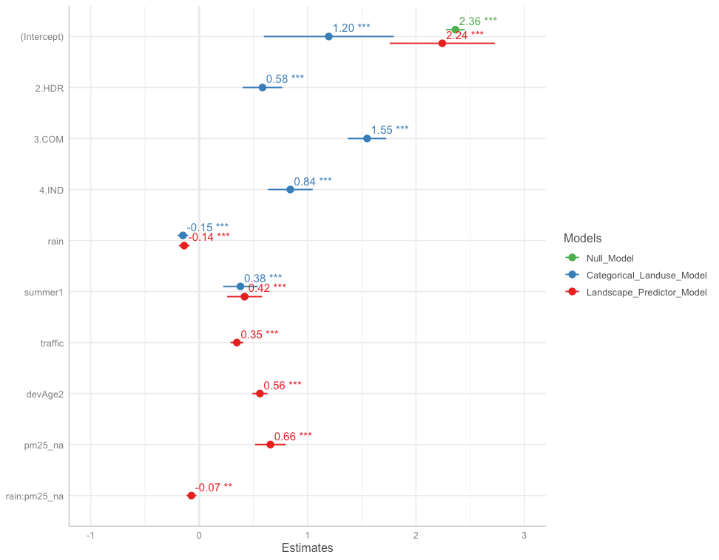

**Figure 4.10** Model coefficients for the Null Model (green), Categorical Land Use Model (blue), and Landscape Predictor Model (red).

**4.4.2 Total Suspended Solids**

Based on linear models of *ln*-transformed TSS versus individual predictors, the strong predictors identified for copper include: totRES, traffic, sqrt_popn, sqrt_CO2_res, sqrt_CO2_tot, sqrt_CO2_com, sqrt_CO2_road, devAge2 (Fig 4.11). Paved was added to the list because it was a strong predictor for an older version of the model, and paved areas are associated with elevated TSS in stormwater.

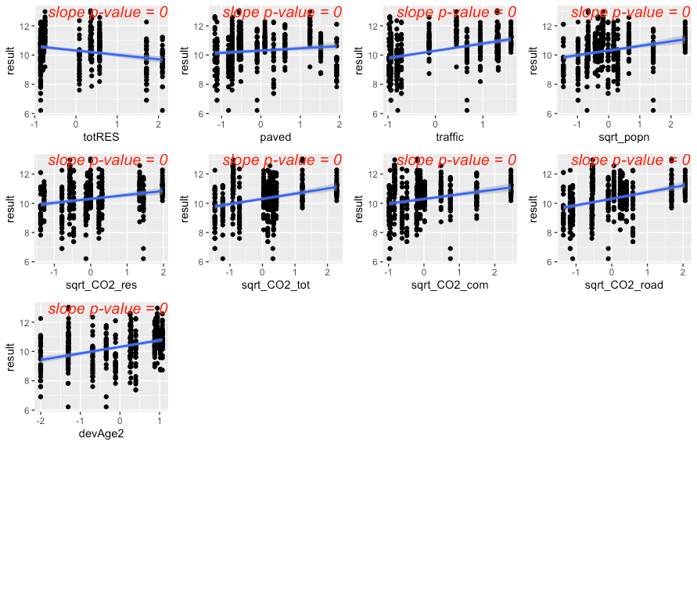

**Figure 4.11** Strong predictors for TSS, showing linear model fit (blue line) for the relationship between *ln*-transformed TSS concentration and each predictor in turn. Although it wasn’t as compelling on its own, the predictor paved was added to the list of strong predictors because it was a strong predictor in a previous model.

The precipitation predictor used for TSS was 1-day cumulative precipitation. There was no evidence of seasonal patterns to TSS in stormwater.

Residuals plotted against fitted values showed signs of slight heterogeneity (Fig 4.12, left plot). Of the variance structures tested, the best fit was for a combination of two variance structures, where residual variation differs by agency *j*, and also by rainfall at each location *i* and date *k*. The parameters δ is estimated by the model.

var(*εijk*) = σ2j × *e*2δ × *rainik*

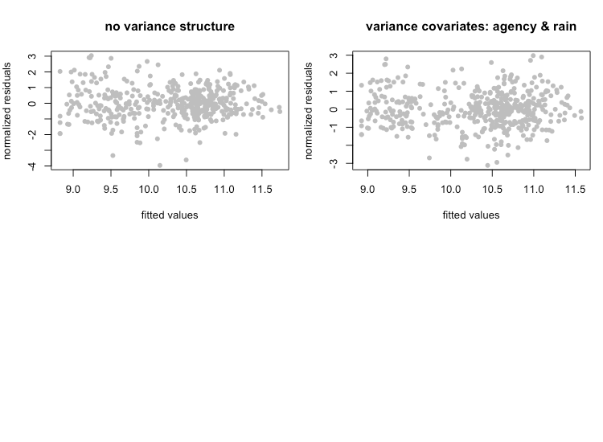

**Figure 4.12** Normalized residuals from beyond-optimal model, with no variance structure (left), and with the best fit variance structure (right).

The best model for TSS is a random-intercept model, where the intercept of the linear model is allowed to shift up or down according to agency. No signs of temporal or spatial auto-correlation were detected in auto-correlation plots or variograms.

With the variance structure and random components set, two possible models emerged to capture the fixed effects:

*ln*(TSS) ~ rain + traffic + paved

*ln*(TSS) ~ rain + traffic + totRES

The AIC score for these two models was very close, with the first model’s AIC score slightly lower (AIC=1246.0 vs. 1246.5, when models were fitted with ML). In the second model, the coefficient for totRES is negative, indicating that increased residential zoning results in reduced TSS in stormwater. This relationship makes sense for the 14 watersheds in our study, but would likely not be appropriate for forested landscapes that have low residential zoning (thus should have high TSS concentrations). As a result, we selected the first model as the most suitable for covering the entire area of the stormwater heatmap. Figure 4.13 shows the model fit for each individual predictor, plotted against data points.

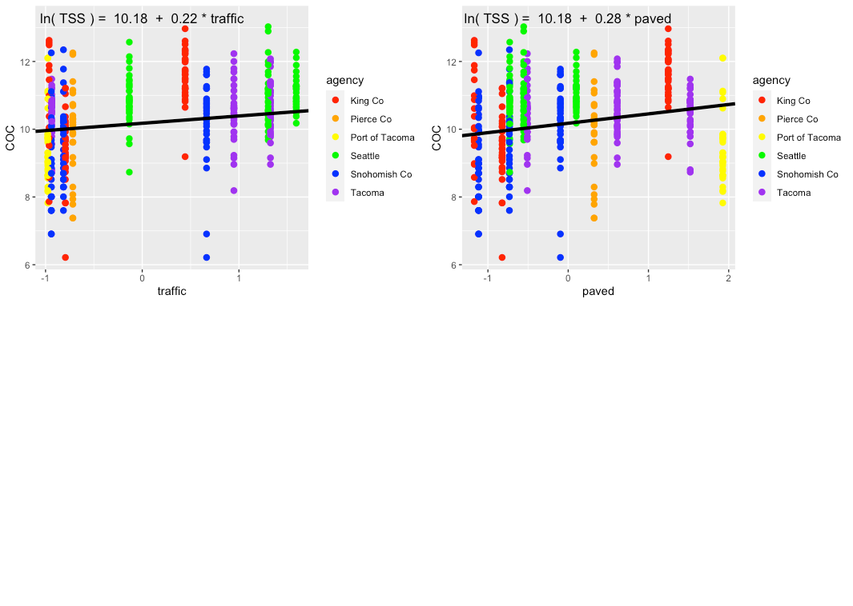

**Figure 4.13** Single-predictor plots for TSS, showing fit of the Landscape Predictor Model to each predictor.

Comparisons between the Null Model, Categorical Land Use Model, and Landscape Predictor Model can be visualized through residuals (Fig. 4.14) and also coefficient values (Table 4.3; Fig. 4.15). The lowest AIC value is for the Landscape Predictor Model, indicating best fit to the TSS data of these three models.

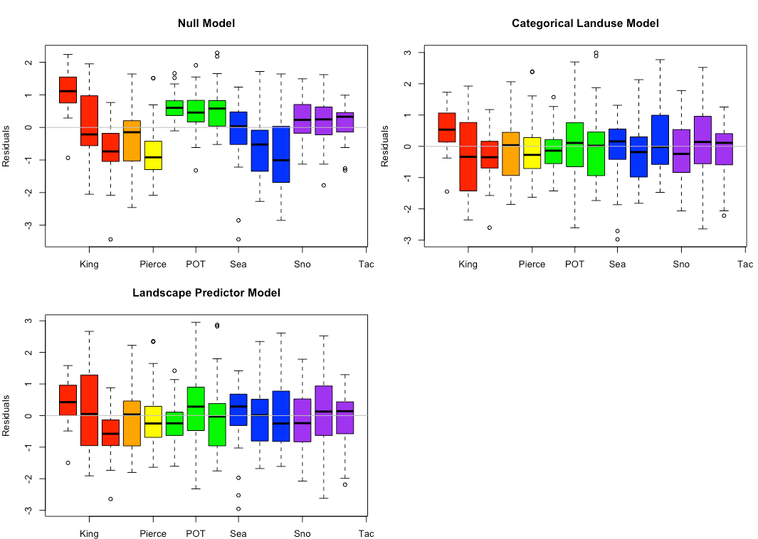

**Figure 4.14** TSS model residuals for the Null Model, Categorical Land Use Model, and Landscape Predictor Models. Each bar represents one watershed, with colors representing agencies.

**Table 4.3** Coefficient values (standard error in parenthesis) for the three TSS models. For the Categorical Landuse Model, the baseline landuse is LDR; all other land use categories are adjustments from the baseline. Final coefficient values for linear mixed effects models are based on fitting with REML.

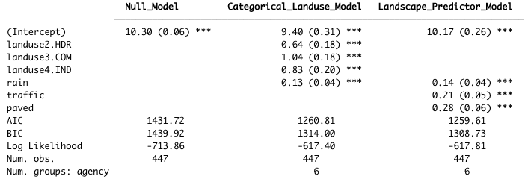

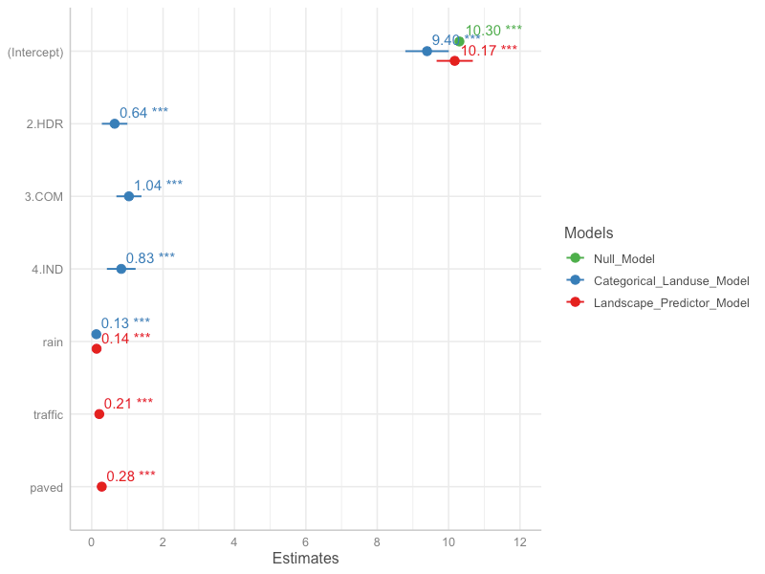

**Figure 4.15** Model coefficients for the Null Model (green), Categorical Land Use Model (blue), and Landscape Predictor Model (red).

**4.4.3 Phosphorus**

Based on linear models of *ln*-transformed phosphorus versus individual predictors, the strong predictors identified for phosphorus include: traffic, sqrt_popn, sqrt_slope, sqrt_CO2_res, sqrt_CO2_tot, sqrt_CO2_road and devAge2 (Fig 4.16). Paved and grass were added to the list because they were strong predictors for an older version of the model, and both are associated with elevated phosphorus in stormwater.

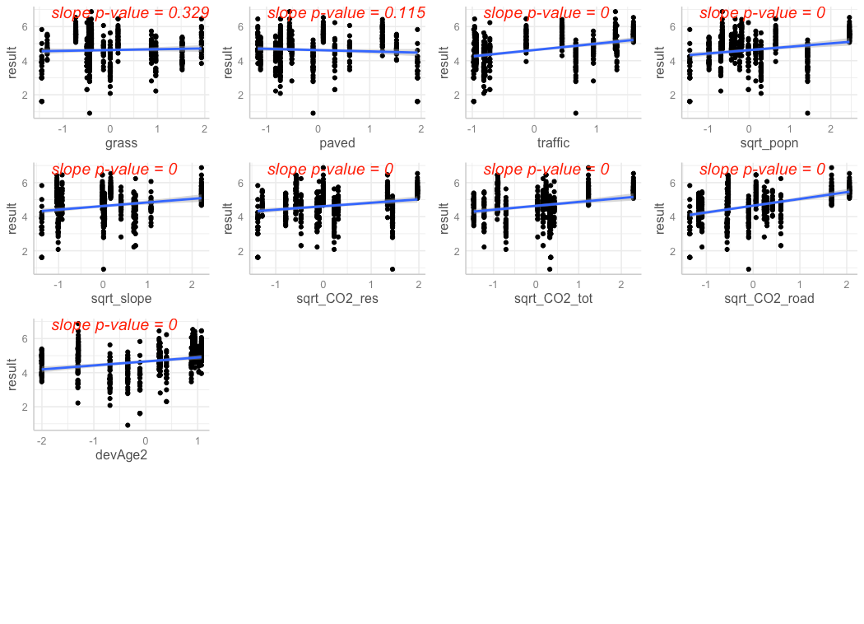

**Figure 4.16** Strong predictors for phosphorus, showing linear model fit (blue line) for the relationship between *ln*-transformed phosphorus concentration and each predictor in turn. Although they weren’t compelling on their own, the predictors grass and paved were added to the list of strong predictors because they were strong predictors in a previous model.

The precipitation predictor used for phosphorus was 21-day cumulative precipitation. In addition, evidence of higher phosphorus concentrations during summer lead us to add *summer* as a categorical predictor to the phosphorus model (where *summer* = 1 during July, August, September, and *summer* = 0 for all other months).

Residuals plotted against fitted values showed signs of slight heterogeneity (Fig 4.17, left plot). Of the variance structures tested, the best fit allows residual variation to differ by agency *j*.

var(*εj*) = σ2j

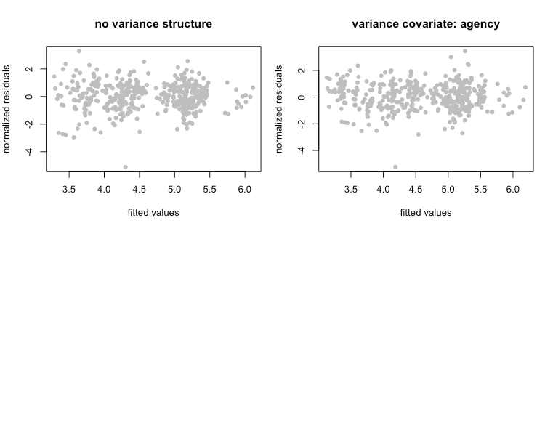

**Figure 4.17** Normalized residuals from beyond-optimal model, with no variance structure (left), and with the best fit variance structure (right).

The best model for phosphorus is a random-intercept model, where the intercept of the linear model is allowed to shift up or down according to agency. No signs of temporal or spatial auto-correlation were detected in auto-correlation plots or variograms.

With the variance structure and random components set, two possible models emerged to capture the fixed effects:

*ln*(phosphorus) ~ rain + summer + grass + paved + sqrt_CO2_road

*ln*(phosphorus) ~ rain + summer + grass + paved

The AIC score for these two models was close, with the first model’s AIC score lower than that of the second model (AIC=830.3 vs. 839.8, when models were fitted with ML). As a result, we selected the first model. Figure 4.18 shows the model fit for each individual predictor, plotted against data points.

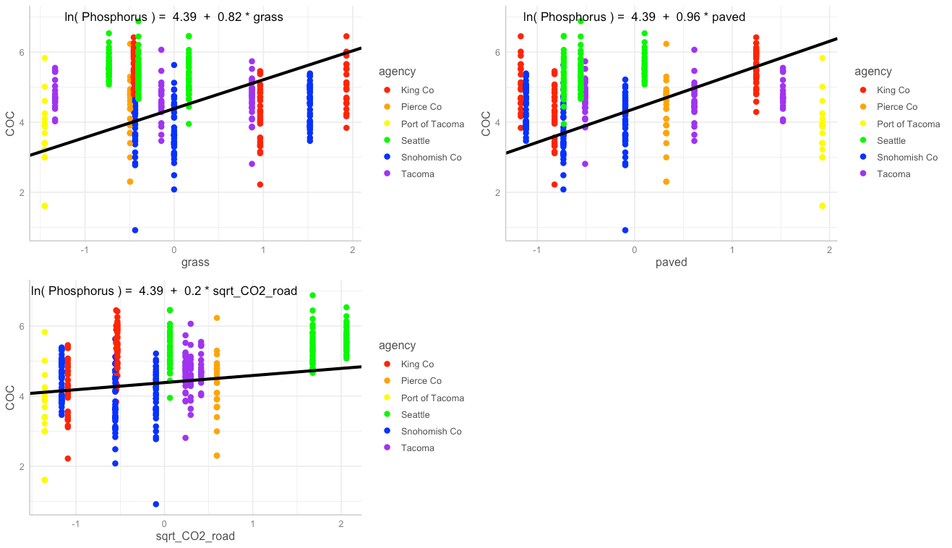

**Figure 4.18** Single-predictor plots for phosphorus, showing fit of the Landscape Predictor Model to each predictor.

Comparisons between the Null Model, Categorical Land Use Model, and Landscape Predictor Model can be visualized through residuals (Fig. 4.19) and also coefficient values (Table 4.4; Fig. 4.20). The lowest AIC value is for the Landscape Predictor Model, indicating best fit to the phosphorus data of these three models.

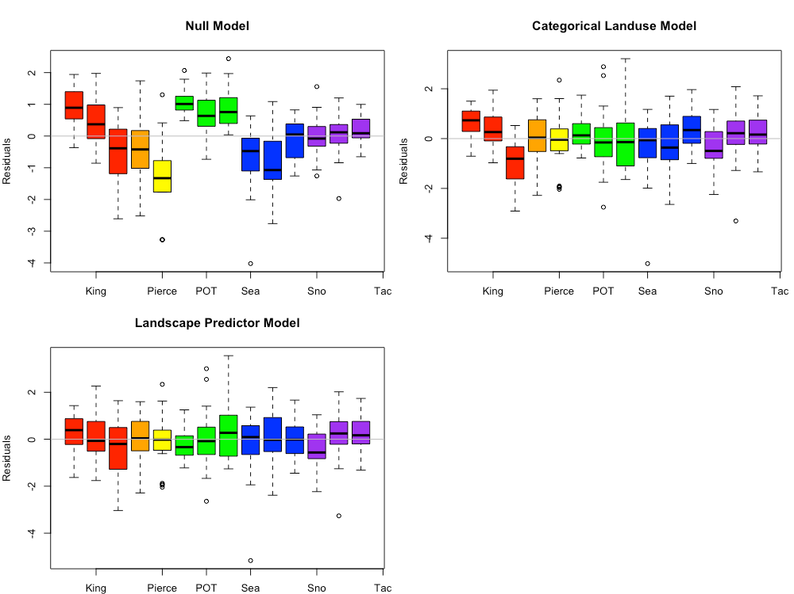

**Figure 4.19** Phosphorus model residuals for the Null Model, Categorical Land Use Model, and Landscape Predictor Models. Each bar represents one watershed, with colors representing agencies.

**Table 4.4** Coefficient values (standard error in parenthesis) for the three phosphorus models. For the Categorical Landuse Model, the baseline landuse is LDR; all other land use categories are adjustments from the baseline. Final coefficient values for linear mixed effects models are based on fitting with REML.

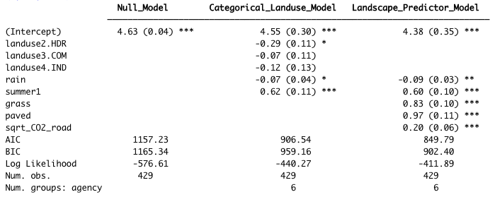

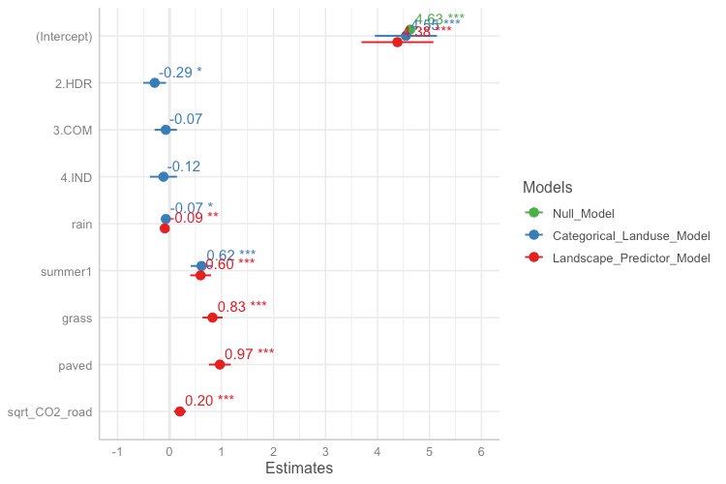

**Figure 4.20** Model coefficients for the Null Model (green), Categorical Land Use Model (blue), and Landscape Predictor Model (red).

**Citation:**

Zuur AF, Ieno EN, Walker NJ, Saveliev AA, Smith GM. 2009. Mixed Effects Models and Extensions in Ecology with R. New York (NY): Springer

1. Phase I Permittees include: cities of Tacoma and Seattle; King, Snohomish, Pierce and Clark counties; Ports of Tacoma and Seattle. For this study, all data were used with the exception of those from Clark County (outside of the Puget Sound region) and Port of Seattle (too different from all other Puget Sound watersheds).
2. See: ~~https://fortress.wa.gov/ecy/gispublic/DataDownload/ECY_CAD_Landuse2010. htm~~ for more information *** NOTE *** this needs to be updated for commerce data!